Project Sponsor: Burns Paiute Tribe
Subbasin: Malheur River Subbasin
Province: Mid Snake
Project Title: Malheur Subbasin Habitat Restoration and Fish Enhancement – Logan Valley Project
Project Number: 200712000

The ISRP was not convinced that this acquisition would provide benefit to fisheries resources. Furthermore, it was not clear on how new management changes would be undertaken and how this would differ from current management practices. The project sponsor was seeking to justify the acquisition for fish through unbiased recommendations provided through the Malheur River Subbasin Assessment and Management Plan and the US Fish and Wildlife Service Bull Trout Recovery Plan. Both documents specifically identify this reach of Lake Creek as a high priority for restoration, especially for bull trout. Due to this approach, the project sponsor acknowledges specific details are limited. The project sponsor has a good deal of data for this area and would like to expand on those recommendations identified in the Subbasin Plan and Recovery Plan.

Area Description
McCoy Creek originates in the Strawberry Mountain Wilderness Area at an elevation of 6400 feet (Figure 1). McCoy Creek flows downstream approximately 3.0 kilometers (km) through US Forest Service managed lands which then flows onto the proposed acquisition lands. McCoy Creek flows through the proposed acquisition lands for a total of 4.0 km which then flows onto the Bonneville Power Administration’s Wildlife Mitigation Lands managed by the Burns Paiute Tribe. McCoy Creek flows through the Mitigation Property for about 2/3 km which then converges with Lake Creek.

Lake Creek originates at High Lake located at an elevation of 7500 feet in the Strawberry Mountain Wilderness. From High Lake, Lake Creek flows approximately 2.0 km to a waterfall that is an upstream barrier to bull trout. From this point, Lake Creek flows approximately 6.3 km through the Strawberry Mountain Wilderness. This section of stream encompasses nearly all the critical bull trout spawning habitat of Lake Creek. From the Wilderness Boundary, Lake Creek flows onto US Forest Service Managed lands for approximately 4.5 km which then flows onto the proposed acquisition lands of the Stanbro Ranch. Lake Creek flows through the deeded land of the proposed acquisition lands for 1.6 km. From this point, Lake Creek flows back and forth between Forest Service managed lands and lands managed by the Burns Paiute Tribe for about 6.3 km. Lake Creek then converges with Big Creek from the east on Tribal land and forms the Malheur River (Figure 1).

The Malheur River originates in Logan Valley on Tribal Wildlife Mitigation Lands and flows down to the property boundary approximately ¼ stream kilometers. The Malheur River flows through the private lands for approximately ¾ km which then flows onto US Forest Service managed lands. At this boundary, Bosonberg Creek flows into the Malheur River from the east. From the confluence of Bosonberg Creek and downstream, the Malheur River is designated National Wild and Scenic for approximately 15 kilometers downstream to the US Forest Service Boundary. If the proposed acquisition land is funded, a total of 56 stream kilometers of continuous bull trout habitat will be controlled by either the US Forest Service or Burns Paiute Tribe with the exception of ¾ river kilometer of the Malheur River in private ownership.
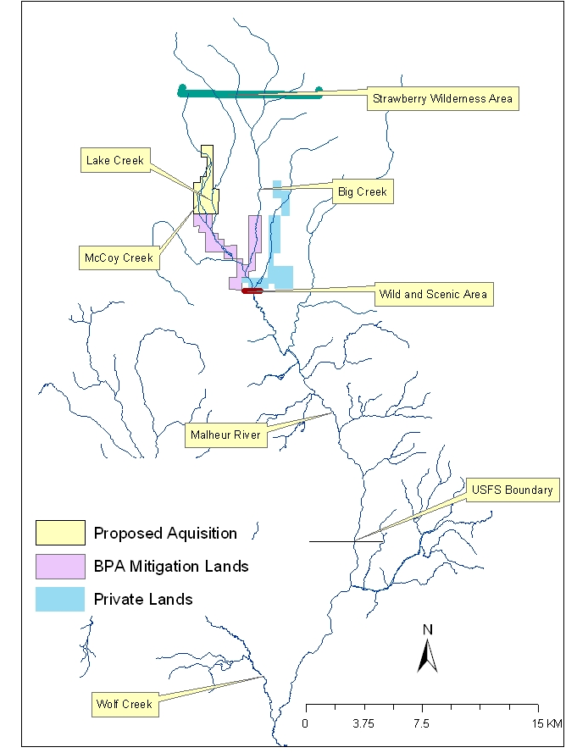

Figure 1 – Map of the project area. With the proposed acquisition, a total of 56 kilometers of habitat can be secured for native fish recovery. All three focal species identified in the Malheur River Subbasin Plan historically utilized these habitats and the area has high cultural significance to the Burns Paiute Tribe. Focal species include: bull trout, redband trout, and chinook salmon.
Native Salmonid use of proposed acquisition
The acquisition shall include the purchase of 4.0 km of McCoy Creek and 1.6 km of Lake Creek. Bull trout historically utilized McCoy Creek but currently are not present. Bull trout currently utilize Lake Creek. Critical spawning habitat, primarily located in the Strawberry Mountain Wilderness area, is located 4.3 km above the northern boundary of the proposed acquisition. A fluvial component of the bull trout population utilizes the Malheur River that have been observed as much as 35 km downstream from Logan Valley (Figure 2)(Schwabe et al.2001). Currently it is evident that fluvial bull trout almost exclusively utilize the Big Creek drainage with very little use of Lake Creek. However, past telemetry projects in the area has identified Lake Creek as over summer habitat for juvenile and subadult bull trout (Figure 3). Habitat degradation has significantly impacted the historic distribution of bull trout in Logan Valley (NPCC 2004, Schwabe et al. 2000).

McCoy Creek and Lake Creek provide habitat for redband trout. Redband trout are a valued resource and have been identified as an aquatic focal species in the Malheur Subbasin Plan. Redband trout utilize these reaches for all life stages, including spawning and incubation (NPCC 2004). Thus, recovery of the habitats in Logan Valley shall not only benefit bull trout, but other native fish species as well.

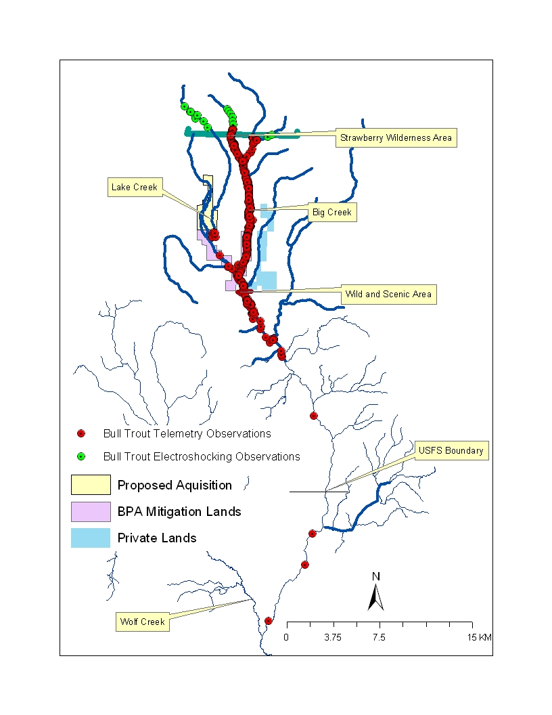
Figure 2 – Bull trout telemetry observation in the Malheur River system. A total of 40 adult bull trout were radio tagged in 2000 and 2001. An additional 10 subbadult bull trout were radio tagged in 2004 and 2005. Distribution surveys were conducted in 2003 and 2004. Map encompasses all bull trout observation in this time period.

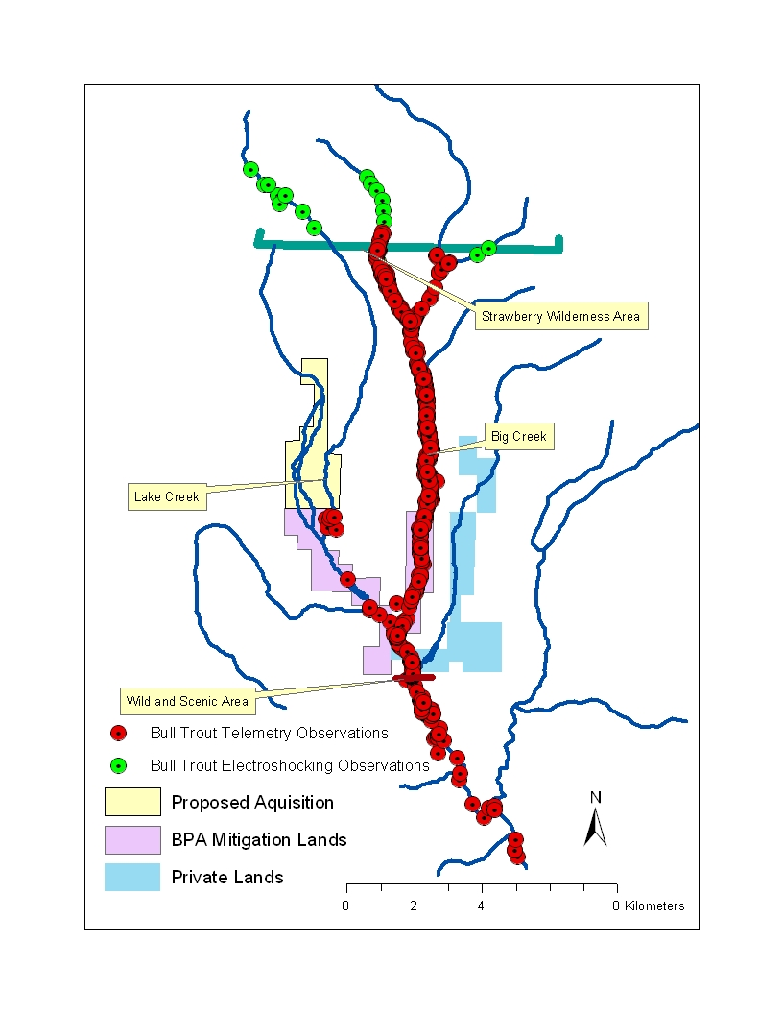

Figure 3 – Bull trout telemetry observation in the Malheur River system. A total of 40 adult bull trout were radio tagged in 2000 and 2001. An additional 10 subbadult bull trout were radio tagged in 2004 and 2005. Distribution surveys were conducted in 2003 and 2004. Map encompasses bull trout observation around the Logan Valley Area.

Past and Current Management of proposed acquisition property

Past management on Lake Creek and McCoy Creek include extensive cattle grazing in the valley. Though there has been evidence of haying operations in the past according to aerial photography from the 1960’s, such practices have been discontinued and the lands have been primarily utilized for cattle grazing in recent years. Grazing practices on the proposed acquisition are noted to begin in May and cease in October. These current and past practices have led to largely degraded riparian conditions, noted of being only 18% of historic or reference condition (NPCC 2004). In addition, current management operations do not allow the recovery of degraded habitat conditions. Continued grazing prohibit the recovery of hardwoods along the riparian corridor. The decrease of riparian condition in Lake Creek has resulted in elevated summer stream temperatures and a decrease in habitat diversity. The Oregon Department of Fish and Wildlife has noted Lake Creek as a thermal barrier to bull trout (Bowers et al. 1993). Tribal stream temperature data note significantly higher temperatures in Lake Creek than in Big Creek and this variation is depicted in the Forward Looking Infra-Red (FLIR) data taken in 1998 (Schwabe et al. 2002)(Figures 4 and 5).

The channel types of the proposed acquisition are similar to those of the Logan Valley Wildlife Mitigation lands. Utilizing Rosgen channel classifications (Rosgen 1998) McCoy Creek is more of an E-Type channel that characteristics include: 1) high sinuosity values, 2) deep narrow channels or small width to depth ratios, and 3) broad floodplain or large entrenchment values. McCoy Creek tends to be a sedge dominated system with sporadic willow dispersed. Lake Creek is more of a C-Type channel that characteristics include: 1) moderate sinuosity values, 2) high width to depth values, and 3) high entrenchment values. Lake Creek has the potential of yielding high density of willow that provide optimal conditions for beaver (Castor canadensis) and beaver dam complexes. Boyd and Zamora (2005) noted that beaver complexes in Lake Creek potentially provide a rise in the water table that result in a significant cooling effect of stream temperatures. Both drainages on the proposed acquisition are wet meadow systems and woody debris play very little role in the ecology and evolution of their perspective stream channel. Due to minimal human impact upstream of the proposed acquisition, aquatic habitats are suspected to be very resilient under favorable management.

Current water management practices impact the habitat conditions in Lake Creek. An existing water right on the proposed property is utilized to constantly irrigate meadow grasses for cattle grazing throughout the summer period. Current water use practices include extensive flood irrigation that includes diverting water into a large number of ditches where the water is “fanned” out over a desired meadow (Figures 6, 7 and 8). There are such a high number of ditches, it is difficult to determine a diversion ditch versus the Lake Creek channel. Even the official water right maps conflicted with current USGS and USFS maps. The Tribe consulted with the watermaster in 2005 and the eastern channel was officially designated as Lake Creek. The water right use period extends from April 1 to October 31. Water withdrawal practices from Lake Creek result in low flow conditions that allow stream temperatures to elevate during the summer period, particularly in July and August. In some instances, water withdrawal has eliminated summer rearing and migratory habitat by dewatering Lake Creek isolating the population of bull trout and other native fish to the headwaters (Figures 9 and 10).

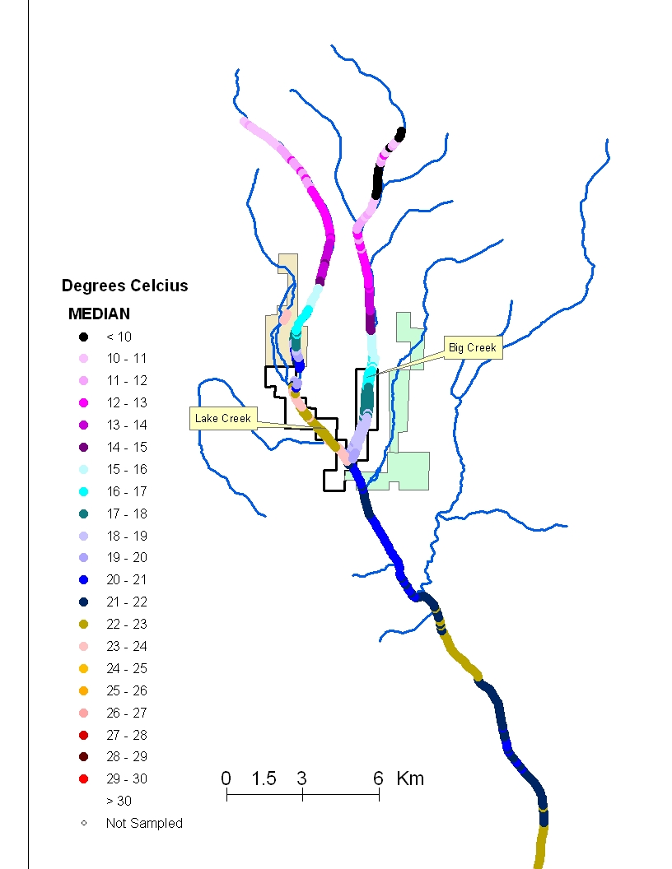

Figure 4.
FLIR flight of the Upper Malheur River and tributaries. August 1997. Note that thermal heating is accelerated in the lower Lake Creek drainage when compared to Big Creek.

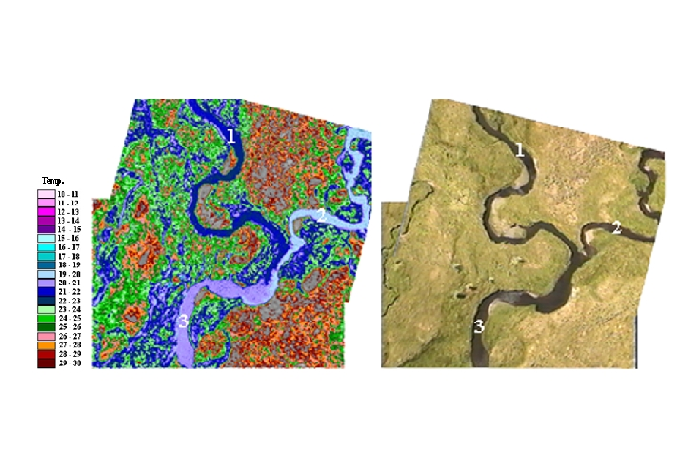

Figure 5.

FLIR photo of Lake Creek (1) and Big Creek (2) where they converge to form the Upper Malheur River (3). August 1997. Note the warmer water temperatures from Lake Creek when compared to Big Creek.

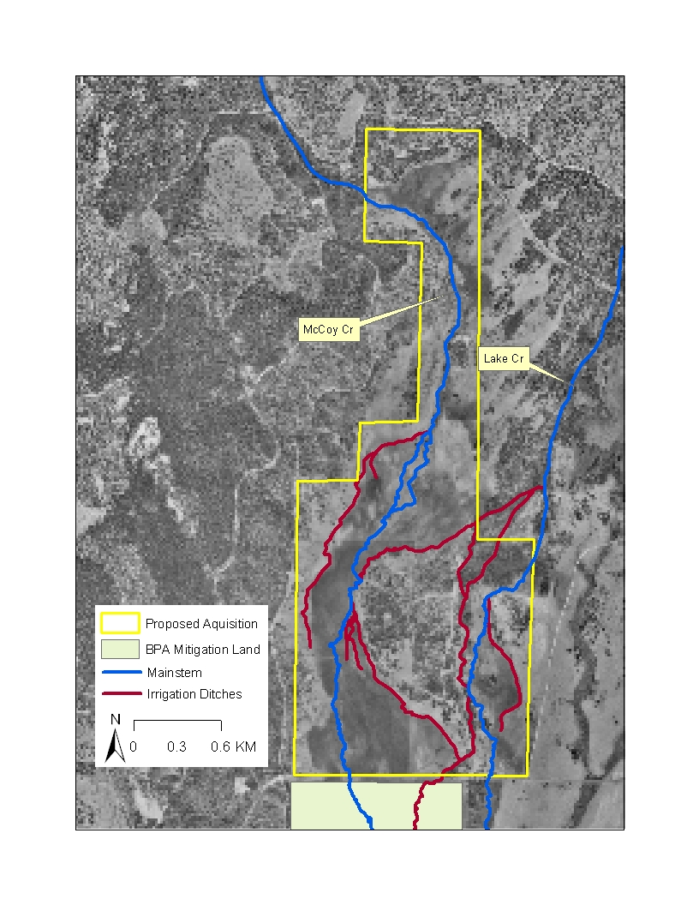

Figure 6.
Proposed acquisition property irrigation ditch system.

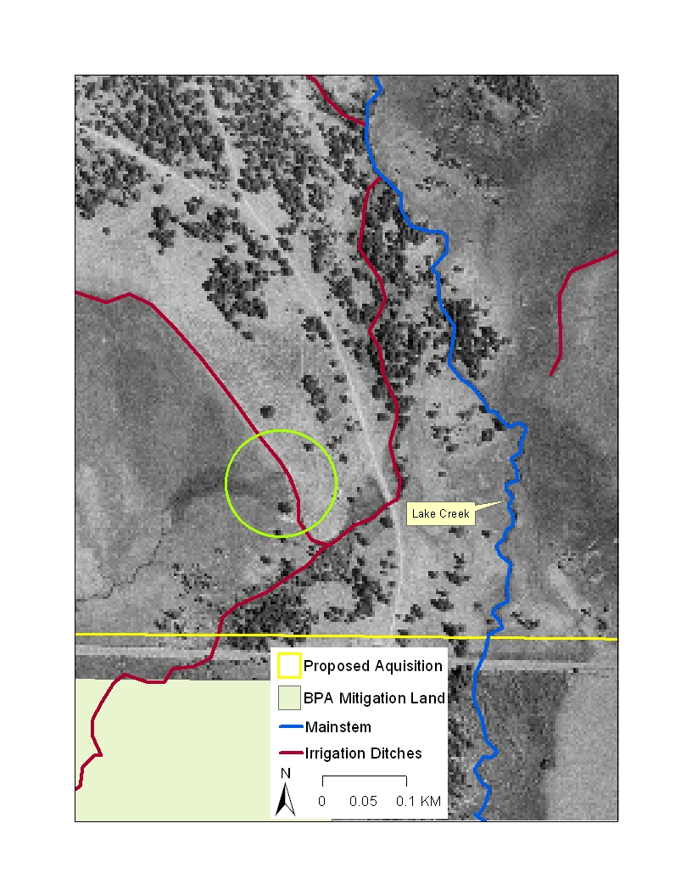
Figure 7
Close up of proposed acquisition property Lake Creek irrigation ditch. Note the area in the circle is flooding into the meadow with no return to the stream.
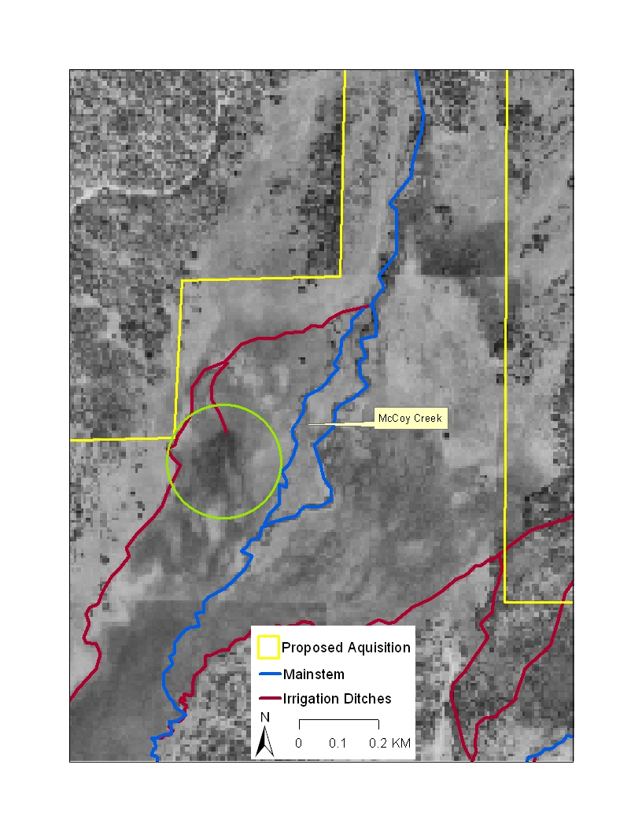
Figure 8
Close up of proposed acquisition property McCoy Creek irrigation ditch. Note the area in the circle is flooding into the meadow with no return to the stream.

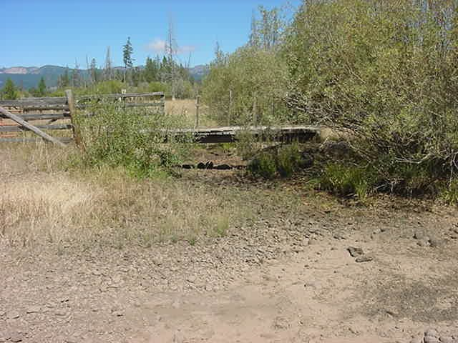

Figure 9.
Mainstem of Lake Creek while water is diverted on proposed acquisition property.

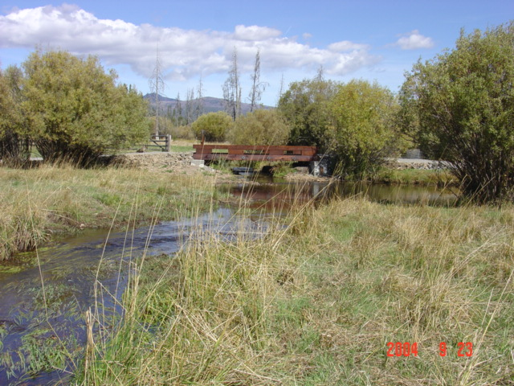

Figure 10.
Same view as figure 9 (after new bridge was installed) when water is not being diverted on the proposed acquisition property.
Forecasted Biological Objectives and Work Elements for FY 2007 - 2009

Biological Objective #2 – Develop a site specific plan to address aquatic limiting factors, in particular, low flow conditions, riparian conditions, channel complexity, and low oxygen levels.
Critical Assumption: We assume that baseline information of the aquatic habitats on the proposed acquisition shall provide staff the knowledge to implement site specific restoration activities that shall address those limiting factors identified in the Malheur River Subbasin Assessment and Management Plan.

Process Description: Collect baseline data on 6.1 km of stream utilizing ODFW Stream Inventory and Rosgen Stream Channel Morphology methodologies. Assessments will seek to identify riparian species present, floodplain widths, channel condition, etc. These assessments will also include detailed information on irrigation ditch locations, irrigated areas, and condition of diversion structure.

Results Expected: Site specific restoration and management activities that shall be incorporated into a detailed management plan for the proposed acquisition.

Biological Objective #3 – Determine the feasibility of the development of an interim non-native put and take fishery with an optimum annual harvest of 650 kg (1,433 lbs).
Critical Assumption: We assume that Logan Valley has good groundwater sources and conditions that are optimal for constructing put and take fish ponds that can be effectively managed for harvest and have very low risk to local native resident fish populations.

Process Description: Project sponsor shall consult with local and private entities to determine the feasibility of constructing ponds for a put and take fishery. The consulted work shall provide a design for site feasibility, engineering design, and estimated costs for construction. The sponsor shall consult with Oregon Department of Fish and Wildlife, Bureau of Land Management, US Bureau of Reclamation and Natural Resources Conservation District due to their local experiences in developing similar projects. The sponsor seeks to initiate feasibility studies with private consultants such as Spring Creek Aquatic Concepts, Inc., but no official consultant has been selected. The risk to native fish can be kept very low. The Tribal Council has not selected a particular fish stock, but staff recommends utilizing a triploid rainbow trout stock as a default species. Triploid rainbow trout are put through a process that sterilizes the trout shortly after the eggs are fertilized, in turn reduces the potential of hybridization with native stocks of O. mykiss. ODFW has been greatly involved in the triploid rainbow stocking program in the local area due to fish stocking efforts in redband trout habitat in the Great Basin. The project sponsor shall build upon the successes the ODFW has with the Triploid program. To reduce risks of escapement, ponds are to be constructed outside the Rosgen (1998) 30-year floodplain width where only extreme events threaten the inundation of the ponds. To reduce the vulnerability of stochastic events and periods of high run off, the project sponsor proposes that excavated material be used to create a berm around the pond. Winter snowpacks average 4 feet in Logan Valley alone, not considering the depths in the higher elevations. Ponds are to be constructed away from natural drainage areas or shall provide sufficient drainage areas for snowmelt. Pond construction adjacent to low elevation ridges within the valley further reduce runoff escapement risks.

Results Expected: A completed feasibility assessment for pond construction, pond construction design and engineering, and proposed estimate of construction costs.

Effectiveness Monitoring: The project sponsor proposes that economical based monitoring is needed to acknowledge that the best scientific principles are utilized by management to provide the Tribe with an effective and successful fishery. If deemed feasible, the project sponsor shall develop a detailed monitoring and evaluation component for the established fishery. Monitoring and evaluation activities should include water quality, creel, and fish growth/condition factor for stocked fish that shall aid management with identifying stocking rates and stock size.

Biological Objective #5 – Improve riparian condition and channel conditions on approximately 4.6 km of stream.

Critical Assumption: We assume that adaptively applying restoration techniques including planting and grazing exclusion can restore normative function to riparian zones and increase their contribution to salmonids abundance and productivity.

Process Description: Project sponsor seek to restore all aspects of stream and riparian function. Prescribe riparian buffers to streams that will include: 1) Complete cattle exclusion from riparian buffers. Buffers shall be set either at 180 feet for each streamside (CREP maximum protection) or Rosgen (1998) 30-year flood inundation area, which ever is greatest. Proceed to plant native hardwoods in suitable areas throughout the 30 year floodplain. Stream and riparian function shall expand beyond limited riparian strip management and include the broad stream processes associated with interactive floodplain restoration.

Results Expected: We would expect to see an increase in hardwood density, habitat diversity, and riparian cover along the stream and within the floodplain. We expect to see an increase in habitat complexity due to increased hardwood densities in beaver dam complexes. We also expect to see increases in the water table or groundwater levels, increase pool habitat, increase shade and observe significant decreases in stream temperatures.

Effectiveness Monitoring: The project sponsor proposes to focus on economical based monitoring. Monitoring activities include photopoint for riparian densities, stream habitat assessments (ODFW 1998), stream temperature monitoring, and groundwater well depth monitoring (Boyd and Zamora 2005). Periodically conduct snorkel surveys on 20% of available stream habitat to determine on site salmonids habitat use utilizing the methods identified in BPA annual report (Schwabe et al. 2004). In addition, periodically sample population density monitoring sites proposed to be developed under project no. 199701900, Evaluation of the Life History of Native Salmonids in the Malheur River Basin, in Lake Creek, McCoy Creek and Crooked Creek to determine local population trend and response to restoration activities in Logan Valley.

Biological Objective #6 – Increase summer base flows and fish migratory connectivity on 4.6 km of stream.
Critical Assumption: We assume that restoring Lake Creek and McCoy Creek to a more historical hydrograph, particularly during the summer and late fall period, shall provide native salmonids connectivity and productivity if other factors such as riparian and floodplain conditions also become favorable.

Process Description: Utilize the existing water right for the benefit of fish and wildlife resources. Given the current data and management direction of adjacent project no. 200000900, Logan Valley Wildlife Mitigation Site, the project proposes to consider current water management practices. Current management operations are to flood irrigate starting in April or when access is feasible to Logan Valley until June 30. All water shall be kept instream from July 1 to the close of the irrigation season that occurs on October 31. Flood irrigation has provided evidence of significant stream temperature cooling in nearby streams (Wenick 2002). In addition, flood irrigation practices on the current Wildlife Mitigation Project suggest a cooling effect on Lake Creek but were not statistically significant (Boyd and Zamora 2005). Since flood irrigation effects are site specific, it is difficult to determine the fisheries benefits on the proposed acquisition. An assessment, as identified in Biological Objective #2, shall evaluate the existing irrigation system and the associated layout of the terrain to determine the possible benefits of such water management practices. It is likely that such evaluation may provide substantial evidence to keep all water instream and all work elements associated with irrigation practices shall be eliminated. If flood irrigation is deemed beneficial for native fish resources, the project sponsor proposes to closely monitor hydraulic function of Lake Creek and implement adaptive management practices to meet the top priority to restore native fish habitats. In addition, proper hydraulic control structure and fish screens shall be installed.

Results Expected: Project sponsor expects to observe a decrease in stream temperatures in Lake Creek and McCoy Creek and a return to more normative hydraulic flows in both drainages. Increase flows are expected to provide the necessary water resources needed for all life cycles of native resident salmonids. For bull trout, migratory and summer rearing habitat is expected to see increased habitat utilization. For redband trout, similar improvements are expected with the addition of improved spawning and incubation conditions. Increase in Lake Creek flows will connect the upper 15 km of seasonally isolated habitat to the local population of native salmonids in the Upper Malheur River system.

Effectiveness Monitoring: The project sponsor proposes to focus on economical based monitoring. Monitoring activities include photopoints for riparian densities, habitat surveys (ODFW 1999), stream temperature monitoring, and groundwater well depth monitoring (Boyd and Zamora 2005). Periodically conduct snorkel surveys on 20% of available stream habitat to determine on site salmonids habitat use utilizing the methods identified BPA annual report (Fenn et al. 2004). In addition, periodically sample population density monitoring sites proposed to be developed under project no. 199701900, Evaluation of the Life History of Native Salmonids in the Malheur River Basin, in Lake Creek, McCoy Creek and Crooked Creek to determine local population trend and response to restoration activities in Logan Valley. Lastly, the sponsor would suggest periodically setting a weir trap to monitor fluvial bull trout counts through the property.

Biological Objective #7 – Restore and Protect 700 acres of upland, forest and wet meadow habitats.

Critical Assumptions: We assume that implementing controlled disturbances will promote productive habitats for terrestrial and amphibian population if ecological processes are maintained across their home range.

Process Description: We will conduct thinning on 1) lodgepole pine, 2) Douglas fir and 3) ponderosa pine. Ponderosa pine will only be cut when all other species are removed and additional thinning is still needed. The resulting tree stand will include a variety of age classes. Project staff will perform all work with chainsaws. Within the thinning process, not all trees will be felled but some will be cut to create snags for the benefit of many avian species including the Pileated Woodpecker, a terrestrial focal species identified in the Malheur River Subbasin Assessment and Management Plan (pg. 48). Approximately 10 snags per acre will be created. We will try to reestablish aspen stands with the cooperation of the U.S. Forest Service. To maintain genetic integrity within the Valley, we will attempt to receive stock from aspen stands that currently exist and are under management of the U.S. Forest Service. Stock will be dug in late fall after leaves have fallen from the plants. Each plant will contain at minimum a 1 foot lateral root system. Plants will be stored in a cold and dark environment until mid April when access to the valley becomes available and planting begins. After planting, wildlife fences will be installed to prevent herbivory. Enclosures will be approximately 50 feet square. Aspen will be spaced evenly within the enclosure. We anticipate developing 10 aspen stands with a minimum of 20 trees each with planting. Fencing will be removed once aspen grow beyond the herbivory line. Wet meadows will be irrigated from April through June during high water flows, unless flows begin to decrease earlier than June, water will be left in-stream for fish habitat. Historically this would have occurred naturally but due to past land uses stream channels have begun to incise, the water table has lowered, and consequently flood events occur less often.

Results Expected: We expect our management efforts will result in re-establishment of willow and aspen communities and expansion of their range, will increase biomass availability to terrestrial wildlife species, will increase frequency and density of riparian vegetation, will decrease lodgepole pine and Douglas fir encroachment in forest communities and protect upland sites from cattle degradation.

Effectiveness Monitoring: Vegetation response to management will be monitored through three different methods: aerial photos, willow monitoring and vegetation transects. Terrestrial response will be monitored by point counts, amphibian surveys (both passive and active methods) and small mammal traps. Ungulate use is difficult to determine on this Mitigation Site Due to the large home range of most ungulates it is difficult to assess actual use of the Site vs. travel through the Site. In addition, vegetation is often 2-3 feet tall making pellet counts an inappropriate method to assess ungulate use. Therefore, the Tribe will work with CBFWA, Wildlife Committee in establishing standardized M&E strategies for wild ungulates.

References

Bowers, W.L., P.A. Dupee, M.L. Hanson, and R.R. Perkins. 1993. Bull trout population summary, Malheur River basin. ODFW, Hines, OR.

Boyd, C. and J. Zamora. 2005. Final Report on Research Activities in Logan Valley.
Eastern Oregon agricultural Research Center. United States Department of Agriculture. Burns, Oregon.

Fenn, K., J. Fenton, Schwabe, L., S., and R. Perkins. 2005. 2004 Annual Report. “Evaluation of the Life history of Native Salmonids in the Malheur Subbasin”: Project No. 1997-01900.\

Northwest Power Planning Council (NPPC). 2004. Columbia River Basin Fish and Wildlife Program. NPPC, Portland, OR.

Oregon Department of Fish and Wildlife (ODFW) 1998. Aquatic Habitat Inventory Intermediate Level Stream Survey. Portland, OR.

Rosgen, D., and L. Silvey. 1998. Field Guide For Stream Classification. Wildland Hydrology Books. Pagosa Springs, Colorado.

Schwabe, L., M. Tiley, R. Perkins, D. Gonzalez, W. Bowers, R. Rieber, A. Mauer, S. Bush, C. Tait. 2000. 1999-2000 Annual Report. “Evaluation of the Life history of Native Salmonids in the Malheur River Basin: Project No. 1997-01900, 120 electronic pages, (BPA Report DOE/BP-00006313-1)

Schwabe, L., S. Namitz, J. Fenton, R. Perkins, P. Spruell, D. Gonzalez, J. Wenick, W. Bowers, R. Rieber, A. Mauer, S. Bush, C. Tait. 2001. 2000-2001 Annual Report. “Evaluation of the Life history of Native Salmonids in the Malheur River Basin: Project No. 1997-01900, 189 electronic pages, (BPA Report DOE/BP-00006313-2)

Schwabe, L., J. Fenton, R. Perkins, J. Wenick, T. Walters, W. Bowers, R. Rieber, A. Mauer, A. Miller, J. Soupir, C. Tait. 2002. 2001-2002 Annual Report. “Evaluation of the Life history of Native Salmonids in the Malheur River Basin: Project No. 1997-01900, 143 electronic pages, (BPA Report DOE/BP-00006313-3)

Wenick, J.J., D. Gonzalez, and A. First Raised, 2002. Logan Valley Management Plan. Burns Paiute Tribe. Burns, OR.

